**Preparation for CA2 in Week 17**

**Important:**

**Clone this vmware image after you have installed the Active Directory on the Windows Server 2016 (WinSrv2016_1).**

1. From your VMware Workstation, shutdown your **Windows Server 2016** virtual image. **Right click** your virtual machine, “**WinSrv2016_1**” and select “**Manage**” then “**Clone**” as show in Figure 1.

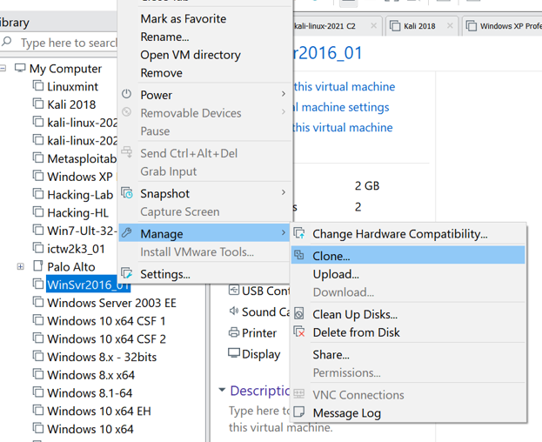

Figure 1

2. Click “**Next**” as shown in Figure 2.

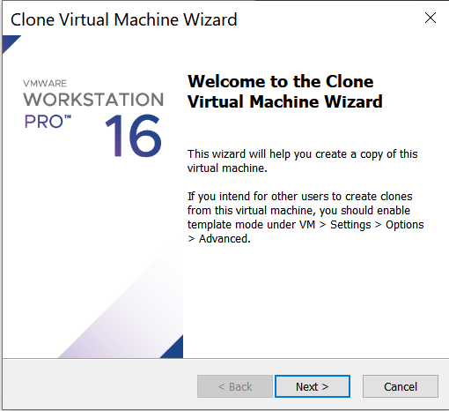

Figure 2

3. Click “Next” to continue as shown in Figure 3.

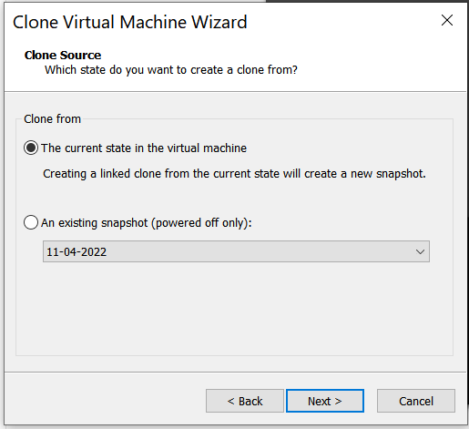

Figure 3

4. Select “**Create a full clone**” and click “Next” to continue as shown in Figure 4.

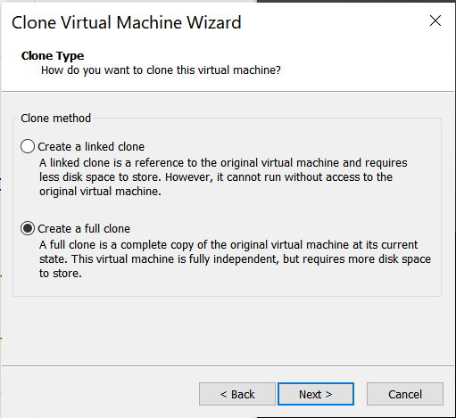

Figure 4

5. Rename to “**WinSvr2016_1 AD**” in Figure 5 and click “**Finish**” to continue.

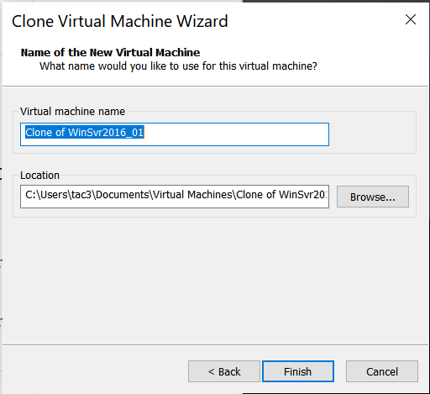

Figure 5

6. Click “**Finish**” to complete the cloning as shown in Figure 6a. You have successfully cloned “**Windows Server 2016 AD”** virtual image shown in Figure 6b. Do not use this cloned **Windows Server 2016** **AD** image until **week 17**. It will be needed for the **CA2** in **week 17**.

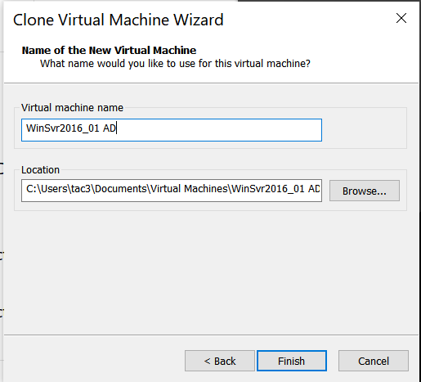 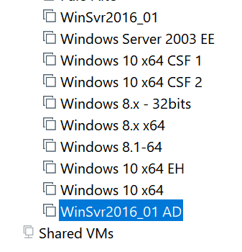

Figure 6a Figure 6b

~ End ~